1.Title / Content Area: | European Political Cartoons | 
2. Developed by: | Sally K. Dickson
3. Grade Level: | 8
4. Essential Question: | How do we analyze political cartoons so that we can decipher what the artist is trying to tell us about an event or point in history?
5. Contextual Paragraph | Political cartoons, also known as editorial cartoons, have been used for centuries as a means of expressing points of view on various political, economic, or social issues. These cartoons are so effective because even those with limited reading skills are often able to understand the idea that is being communicated through the use of symbols, caricatures, and exaggeration. Understanding how to analyze political cartoons offers new insight into the thoughts and ideas surrounding a particular event or time period.

Annotated Resource Set (ARS)
Phase I

6. Resource Set
European Diligence | The Times | One of the people's saints for the calendar of liberty 1852 | I volatori. Les messieurs qui volent | Goods will be so much cheaper. | Unrecognizable
1779 | 1783 | 1852 | 1880 | 1888 | 1914-1918
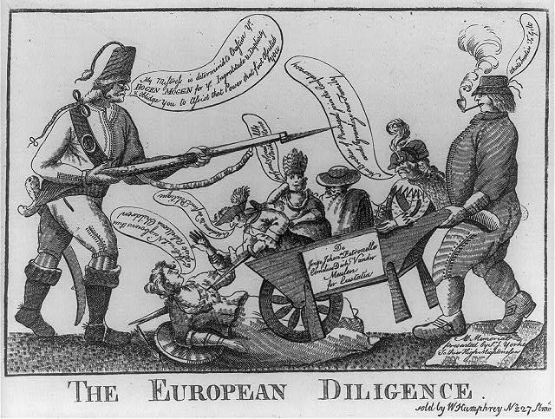 | 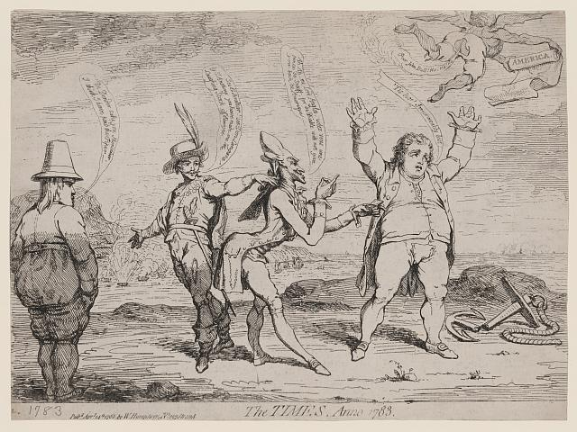 | 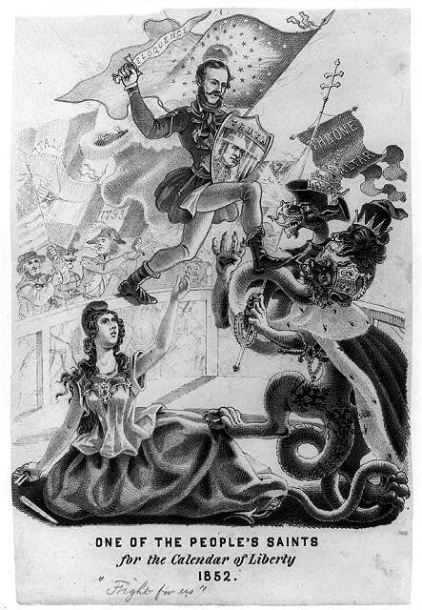 | 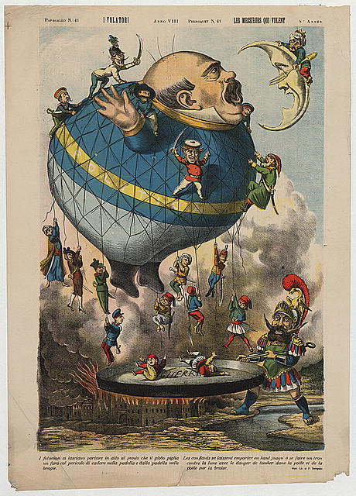 | 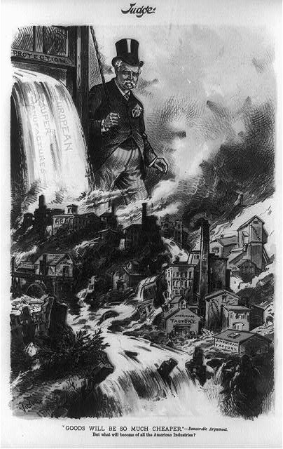 | 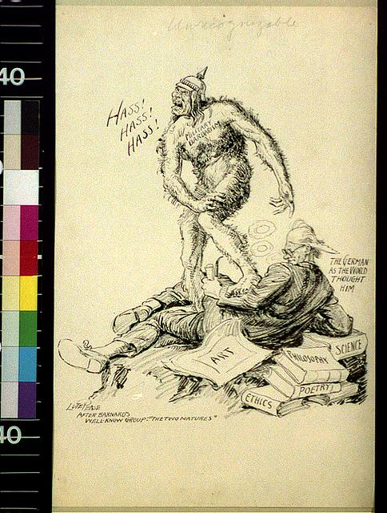
http://www.loc.gov/pictures/resource/cph.3a45634/ | http://www.loc.gov/pictures/item/2004676762/ | http://www.loc.gov/pictures/item/2008661536/ | http://www.loc.gov/pictures/item/2002722664/ | http://www.loc.gov/pictures/item/90707745/ | http://www.loc.gov/pictures/item/acd1996005975/PP/

Well, What are you going to do about it? | Unchained | He Made the Trains Run on Time | Europe is Getting Hot | Viewing with Concern | Hold It… wait for me!
1915 | 1935 | 1941 | 1944 | 1962 | 1989
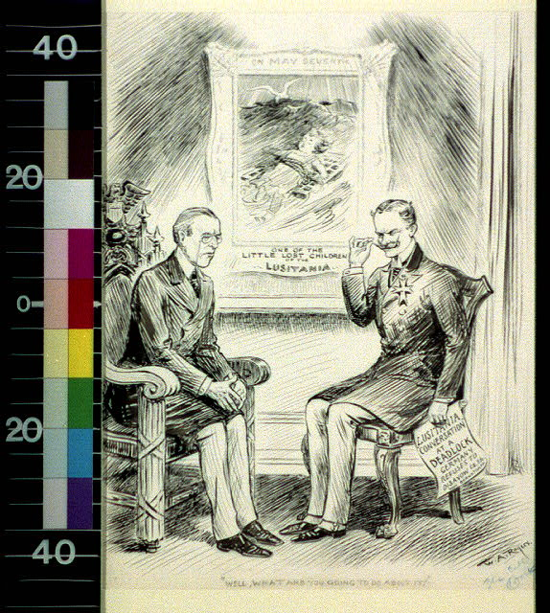 | 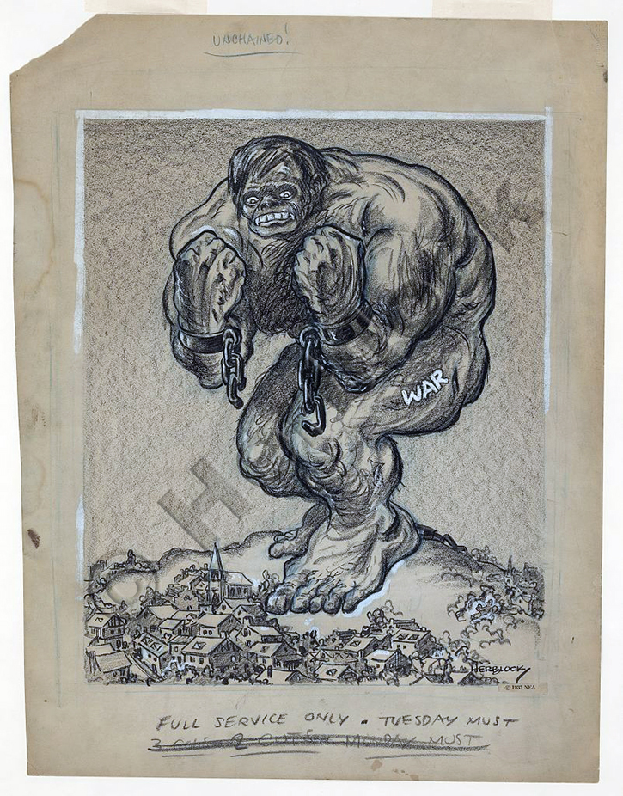 | 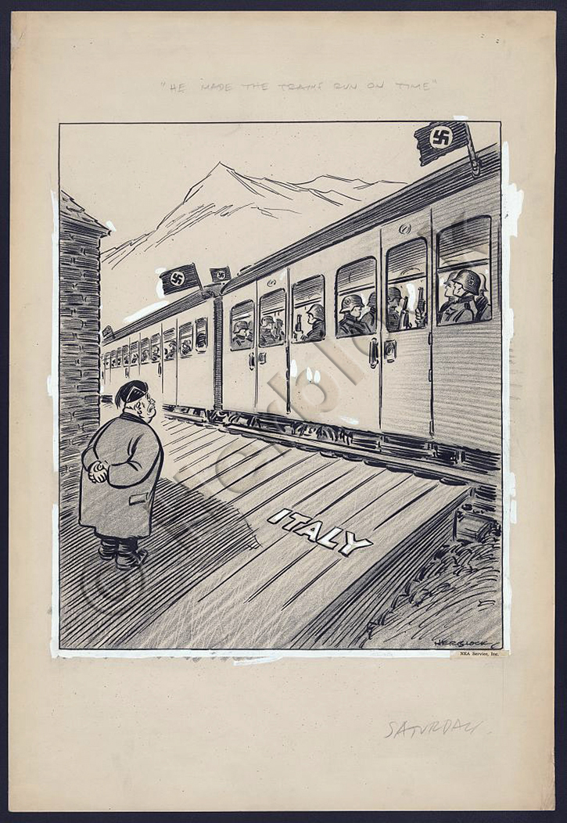 | 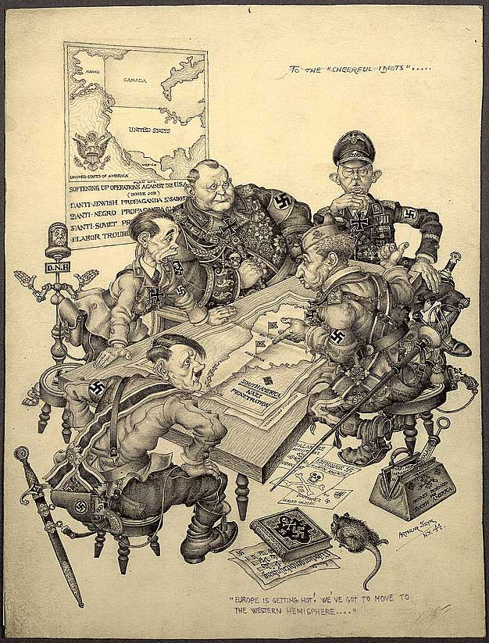 | 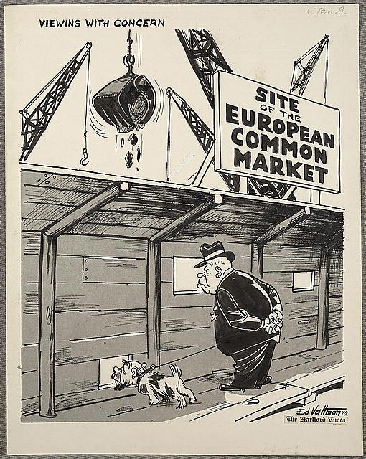 | 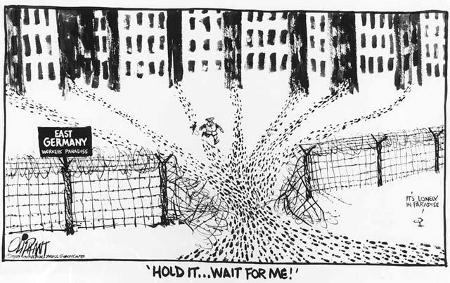
http://www.loc.gov/pictures/item/2010717742/ | http://myloc.gov/Exhibitions/herblock/PsycopathicWard/ExhibitObjects/Unchained.aspx | http://myloc.gov/Exhibitions/herblock/PsycopathicWard/ExhibitObjects/HeMadetheTrainsRun.aspx | http://www.loc.gov/rr/print/swann/szyk/szyk-ex.html | http://www.loc.gov/rr/print/swann/valtman/presentation.html | http://www.loc.gov/exhibits/oliphant/part2.html

Phase II
Foundations Annotations
7. Curriculum Connections

Social Studies

8. Curriculum Standards

(20) Culture. The student understands the relationship between the arts and the times during which they were created. The student is expected to:
(A) identify significant examples of art and architecture that demonstrate an artistic ideal or visual principle from selected cultures;
(B) analyze examples of how art, architecture, literature, music, and drama reflect the history of cultures in which they are produced; and
(C) identify examples of art, music, and literature that transcend the cultures in which they were created and convey universal themes.

9. Content & Thinking Objectives

Students will understand the use of political cartoons to portray social, political, and economic viewpoints through humor and exaggeration.

10. Inquiry Activities & Strategies

Have students analyze one or more cartoons and decide the cartoonist’s point of view or how much it tells about the events of the time.
Students should discuss how the political cartoons have changed over time and what has remained the same.
Without any background knowledge, have students analyze a cartoon. Can they decipher when it was drawn, from or about what country or countries, and what message the cartoonist is trying to impart?
Have students discuss the themes of the cartoons and compare to other historical or current events. Are the themes in the cartoon contemporary to those dates only or do they recur?

11. Assessment Strategies

Have students design their own political cartoon based on a current or historical European event. Let the class analyze the cartoon to see how close they come to the point of view being portrayed.

Other Resources
15. Web Resources

Cartoon Analysis Form: http://www.eiu.edu/eiutps/Cartoon%20Analysis.pdf (designed by Eastern Illinois University)
It’s No Laughing Matter: http://memory.loc.gov:8081/ammem/ndlpedu/features/political_cartoon/ (Library of Congress)

16. Secondary Sources

17. Print and Other Media Resources

3. One of the People’s Saints: http://loc.harpweek.com/LCPoliticalCartoons/IndexDisplayCartoonMedium.asp?SourceIndex=Topics&IndexText=Catholic+Church&UniqueID=41&Year=1852
7. Well, What are you going to do about it?
http://www.pbs.org/lostliners/lusitania.html
8. Well, he made the trains run on time.
http://en.wikipedia.org/wiki/Benito_Mussolini
10. Europe is getting hot
http://www.historylearningsite.co.uk/Nazi_leaders.htm
11. Viewing with Concern
http://en.wikipedia.org/wiki/European_Economic_Community
12. Hold it…wait for me
http://germanhistorydocs.ghi-dc.org/sub_image.cfm?image_id=3024

